This job aid describes how to:
- Search for a Member’s PSI or ERD
- Search for a Household’s PSI or ERD

Search for a Member’s PSI or ERD
From the MassHealth Member and Provider Services home page:
- Click HIPAA Privacy.
- Click Member Search.
The Member Search panel is displayed. On the Member Search panel:
- Enter the Member ID.
- Click Search.
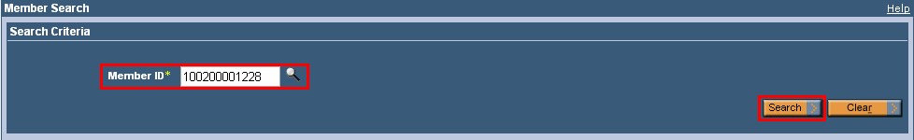
The Search Results panel displays. On the Search Results panel:
- Click the Member ID.
The Member Data and the Member Maintenance panel display. On the Member Maintenance panel:
- Click Member Auth REP/PSI. The Member Auth Rep PSI Information panel displays, showing the member’s ERD and/or PSI and their demographic information.
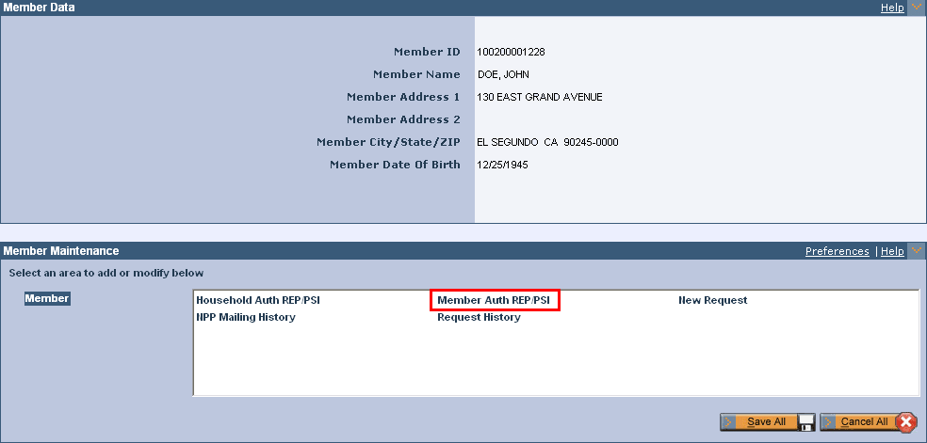
Search for a Member’s PSI or ERD - Continuation
On the Member Auth Rep PSI Information panel:
- Click Case ID Number. The Household Auth Rep/PSI Header Information and the Household Auth Rep PSI Information panels display below the Member Auth Rep PSI Information Panel.
