This job aid describes how to:
- Verify a member’s eligibility using the Provider Online Service Center

Access Verify Member Eligibility
From the Provider Online Service Center home page:
- Click Manage Members.
- Click Eligibility.
- Click Verify Member Eligibility. The Check Member Eligibility panel is displayed.
Enter Member and Provider Information
On the Check Member Eligibility panel:
- Select the Provider from the drop-down list.
- Enter the Member ID.
- In the From Date of Service and To Date of Service fields, enter the date range for the search.
Note: Both fields automatically default to the current date, but you can modify either field as desired.
- Click Search.
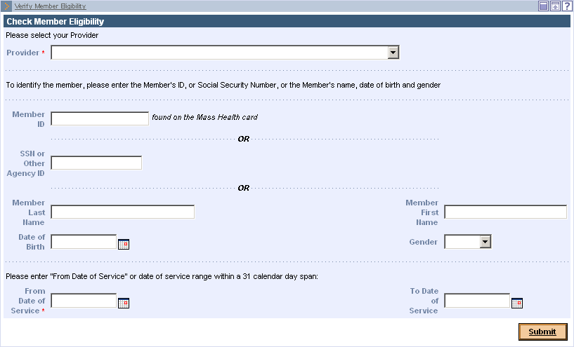
Confirm Member Information
On the Member Eligibility panel:
- Confirm the member’s information including:
- Member Name
- Member ID
- Provider ID
- Date of Service
- Local Office Code
- Once you have confirmed the member’s information, click the Eligibility tab.
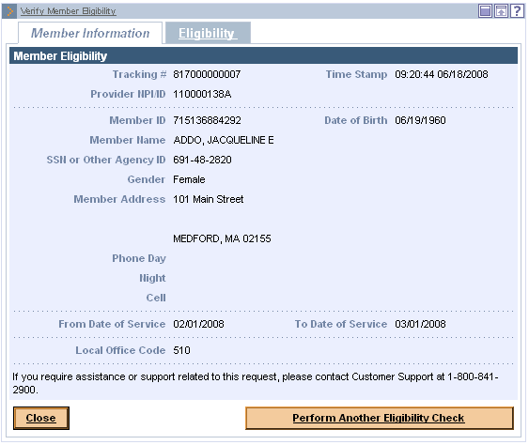

Verify Eligibility Status
On the Dates of Eligibility panel:
- Click the date range to view the member’s eligibility details.
After verifying the member’s eligibility status, do one of the following:
- To end the process, click Close.
- To verify another member’s eligibility, click Perform Another Eligibility Check.

