The Privacy Office receives a request from a member or his authorized representative for documents containing the member’s data. This job aid describes how to:
- Process a member access request

Enter New Member Request
From the NewMMIS home page:
- Click the HIPAA Privacy tab.
- Click Member Search. The Member Search Criteria panel is displayed.
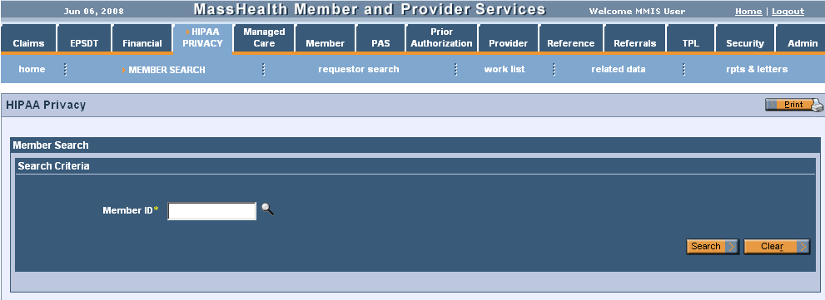

Search for Member
On the Member Search Criteria panel:
- Enter the Member ID.
- Click Search.
On the Search Results panel:
- In the list of search results, click the desired Member ID.
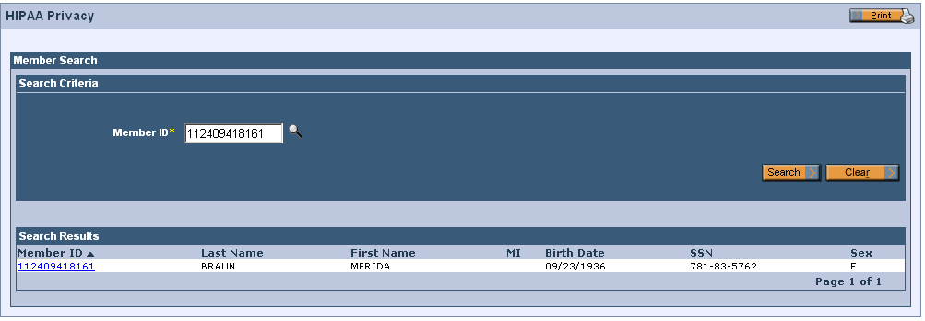
Enter Member Request
On the Member Maintenance panel:
- Click New Request.
On the New Request panel:
- Select Access.
- Click Add.
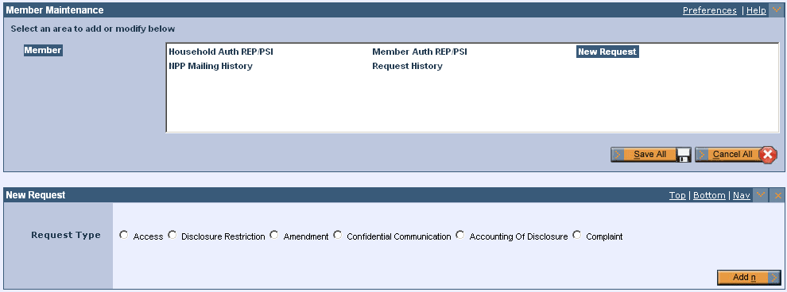
Enter Request Information
On the Access Request Information panel:
- Select the appropriate Purpose.
- Enter the required Request Date.
- Select your name from the Approved By field drop-down list and appropriate staff member in the Assigned To drop-down list.
- Select the appropriate Status of Requests from the drop-down list.
- Enter the Status Change Date. If left blank, the current date will autopopulate upon saving.
- The Request Comment Information panel also opens. More information can optionally be added in this free form text field. Click New.
- Comment Request Maintenance panel opens below. Click Add after entering the comment.
- Click Save All.
- Click DRS on the Access Request Information panel.
Retrieve-Redact DRS Information
On the Retrieve-Redact Information panel:
- Select Retrieve DRS Redaction.
- Select Claims History Data, Member Demographic Data, and/or Prior Authorization Data, as required.
Note: Complete other fields as desired to narrow results of search.
- Click Submit. Report is run in overnight batch process.

Retrieve Data
On, the following day, go to the NewMMIS home page:
- Click the HIPAA Privacy tab.
- Click worklist. The Work List panel is displayed.
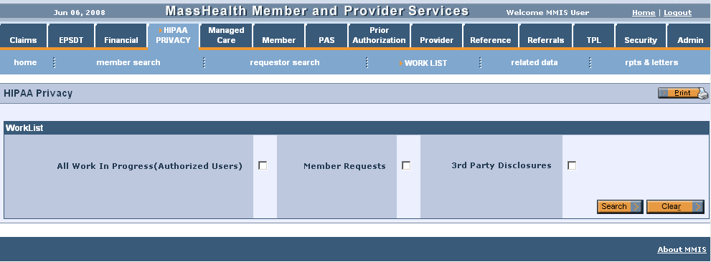
Search Worklist for Requests
On the WorkList panel:
- Select All Work in Progress and Member Requests.
- Click Search.

Select Member Request
On the Member Request List panel:
- Select the appropriate row from the Member Request List panel., and click on Request ID link.
Submit Redact DRS Data Request
On the Access Request Information panel:
- Click DRS.
On the DRS Data Option panel:
- Select Redact DRS Data for Reporting.
Note: Depending on the submitted request, also select the reports you wish to process, such as: Claims History Data, Prior Authorization Data, or Member Demographic Data.
- Click Submit.

Produce Report
On the Claims History List panel:
- Select the RDT box for the rows you want to be excluded.
- Click Report. Reports are produced during a batch cycle at night
- Retrieve report from Document Direct.
Note: To request records for claims dating between 1/1/1987 and 6/30/1996:
  - In NewMMIS, go to: Claims > Reports & Letters > Reports
  - Select either PHI Inquiry Search, Request Type Aging Report, or Request Type Status Report.
  - Enter the desired criteria.
  - Run the report.

