The Privacy Office receives a request from a third party for documents containing member data. This job aid describes how to:
- Process a third-party request
Enter Third-Party Request
From the NewMMIS home page:
- Click the HIPAA Privacy tab.
- Click requestor search. The Requestor Search Criteria panel is displayed.
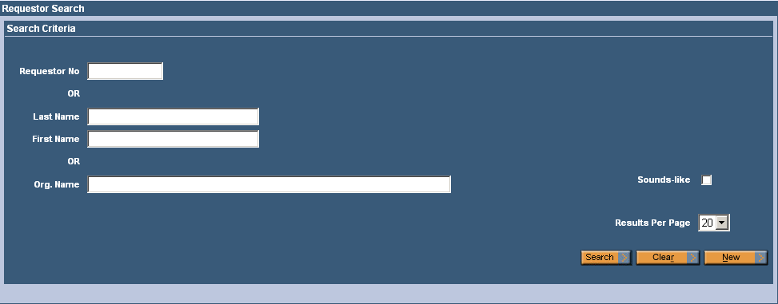

Search for Requestor
On the Requestor Search Criteria panel:
- Do one of the following:
- Enter the Requestor No..
- Enter the Last Name and First Name of the requestor.
- Enter the Org. Name of the requestor.
- Click Search.
On the Requestor Search Results panel:
A. If No Records Found message displays, Requester must be entered as New Requester. Click New on Search Criteria panel.
- Complete fields as required on Requester Edit panel. Click Save All.
- Return to Requester Search and follow steps below under B.

B. If Requestor Data appears under Search Results (i.e. Requester is already entered in system):
- Select the appropriate Requestor Search Results row. Click Requestor Name.

Enter New Request
On the Requestor Maintenance panel:
- Select New Request. The Disclosure Request Information panel is displayed.

Enter Disclosure Request Information
On the Disclosure Request Information panel:
- In the Member ID field, click the Field Search button () to display the Member ID Search/Search Criteria panel. Enter member ID if known. If necessary, go to Member Management to search for member ID by, for example, name, SSN, and/or DOB.
- Member info displays under Search Results. Click Member ID to populate Member ID* field.
- Select the appropriate Purpose from the drop-down list.
- Enter the Request Date.
- Enter your name in the Approved By field.
- Select appropriate Assigned To.
- Enter Open for Status of Request.
- Enter the Status Change Date.
- Select the Subject to Account of Disclosure checkbox, if appropriate.
- Enter Accounting of Disclosure Summary, as appropriate.
- Enter comments in Request Comment Information panel, as necessary.
- Click Save All.
- Click DRS.
Submit DRS Information
On the Retrieve-Redact DRS Information panel:
- Select Retrieve DRS Data for Redaction.
- Select Claims History Data, Member Demographic Data, and/or Prior Authorization Data, as required.
Note: Complete other fields as desired to narrow results of search.
- Click Submit. Report is run in overnight batch process.
Retrieve Data
On, the following day, go to the NewMMIS home page
- Click HIPAA Privacy tab.
Click work list. The Work List panel displays.
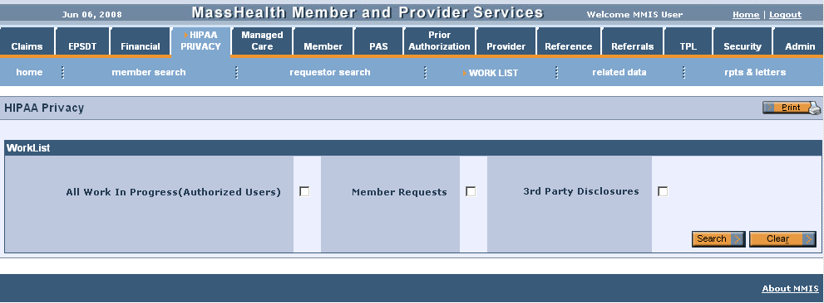
Search Disclosure Requests
On the Worklist panel:
- Select All Work in Progress and 3rd Party Disclosures.
- Click Search.
On the Disclosure Request List panel:
- Select the appropriate row from these three panels: Disclosure Request List, Due Today or Past Due Today. Click Request ID.

Verify Member
On the Disclosure Request Information panel:
- Verify Member ID.
- Click DRS.
Submit Retrieve-Redact DRS Data Request
On the Retrieve-Redact DRS Information panel:
- Select Redact DRS Data for Reporting.
- Note: Depending on the submitted request, also select the reports you wish to process, such as: Claims History Data, Prior Authorization Data, or Member Demographic Data. Click Submit.
Note: Update Request Comment Information panel with comments, if necessary.
Produce Report
On the Claims History List panel:
- Click RDT box for rows to be excluded.
- Click Report. Reports are produced during a batch process cycle at Retrieve report from Document Direct
- Change status of request to Closed-Approved.
- Note: To request records for claims dating between 1/1/1987 and 6/30/1996:
  - In NewMMIS, go to: Claims > Reports & Letters > Reports
  - Select either PHI Inquiry Search, Request Type Aging Report, or Request Type Status Report.
  - Enter the desired criteria.
  - Run the report.

