This job aid includes:
- A brief description of the various sections and functions available in the Provider Online Service Center.
- A step-by-step procedure for completing a common task (searching for a referral) using the Provider Online Service Center.
Introduction
The Provider Online Service Center is a Web-based portal that includes the following functions:
- Enrollment as a MassHealth provider and management of profile information.
- Real-time, interactive claims processing.
- Direct data entry and modification of individual transactions such as Pre-Admission Screening and eligibility verification.
- Viewing of notifications, contracts, reports, metrics, and financial data.
- Links to MassHealth provider and Mass.gov.
Provider Online Service Center Home Page
Key areas of the Provider Online Service Center Home page:
- The tabs along the top provide quick access to information on the EOHHS Mass.Gov Web site for consumers, providers, researchers, and government. It also provides you with a link back to the Home page.
- The navigational links on the left side of the page enable you to access various areas of the Provider Online Service Center.
- The panels on the right side of the page provide links that allow you to access news, publications and updates relating to MassHealth.
- Login button at the lower left corner of the page. After logging in with a unique username and password, providers can access many of the services based on their login.
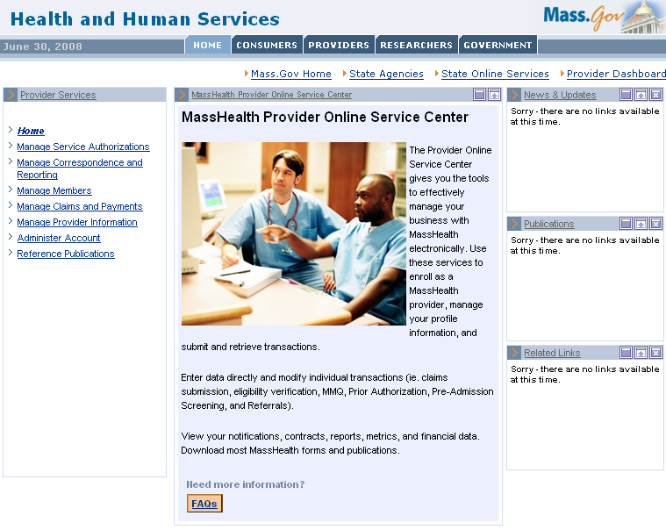

Provider Online Service Center Icons
Icons on the pages will be available to you on some fields in order to assist you when you do not know the required information for the field.

- Clears all the information entered on a search Web page. This button is replaced by a Cancel Service button on Web pages where you are entering new information.

- This set of icons allows you to maximize, restore, or minimize the current page you have open.

- Initiates a search for the information entered on a search Web site. This button is replaced with either a Submit or Save button depending on what kind of Web page you are on.

- You will see that some fields have a magnifying glass after them. This is the Field Search icon and is used when you do not know the required information for the field. Clicking this will launch a new window containing search criteria for that specific field.

- This icon provides you with Web page sensitive help.

- Certain Web pages will be split into sections that allow you to enter search criteria in a variety of ways to search for information, and/or yield better results.

- Fields that have a red asterisk next to them are required fields and must be populated to return results successfully.

- Rather than entering a date manually, you can click the calendar icon to select the date from the pop-up calendar.

Manage Service Authorizations
Manage Service Authorizations allows providers to enter, update, and inquire about PAS, PA, and referrals; request non- emergency transportation for members; and upload and download batch service authorizations.
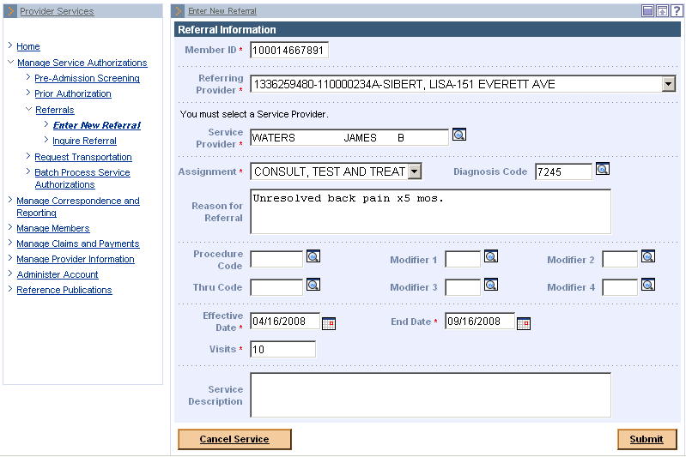

Manage Correspondence and Reporting
Under Manage Correspondence and Reporting, providers can view messages, reports, metrics, notifications, contracts, documents, and submit feedback to EOHHS. Some of the available functions are:
- View Notifications allows providers to see any new EOHHS notices.
- View Broadcast Messages allows providers to see the details of a selected broadcast message.
- Inquire Financial Data allows providers to see payments for the year and month selected and includes a count for each listed category.
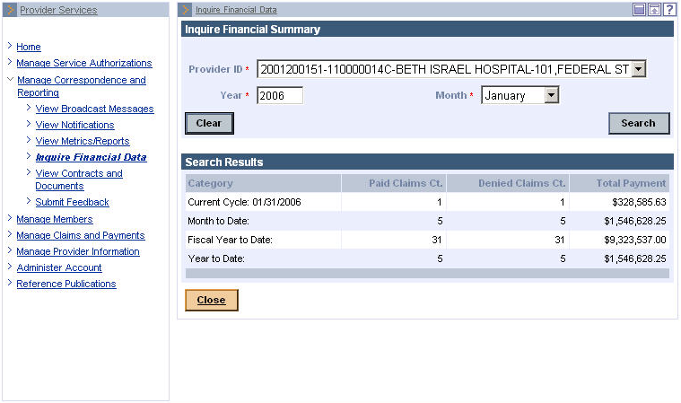

Manage Members
Manage Members lets providers verify member eligibility, enroll and disenroll members for Senior Care Options (SCO) and Program of All-inclusive Care for the Elderly (PACE), and submit Management Minutes Questionnaires (MMQ).

Verify Member Eligibility allows providers a real-time method of checking a member's eligibility status.

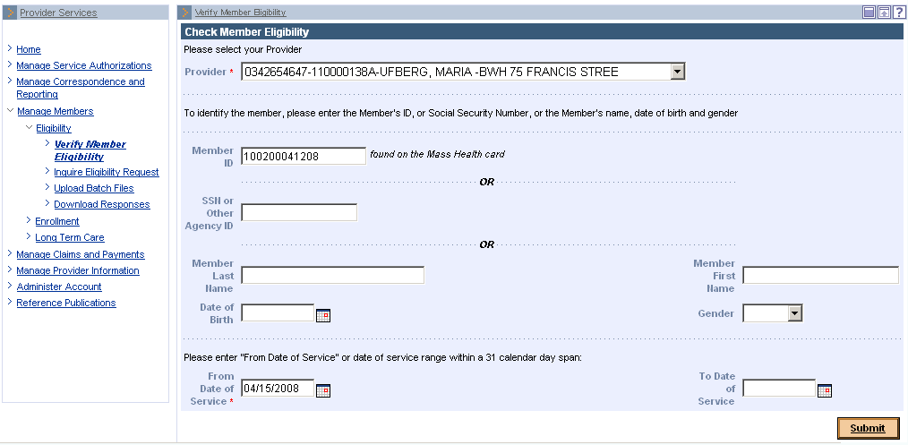

Manage Claims and Payments
Manage Claims and Payments offers real-time, continuous, interactive claims processing and workflow support for suspended claims resolution.
Upon submission of the claim, providers receive instant confirmation of its status. If the claim denies. The system will return specific errors immediately, which allows providers to make edits and resubmit the claim.
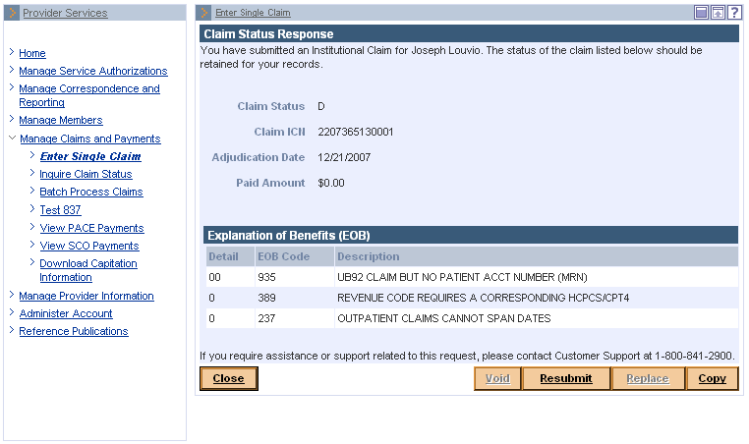

Manage Provider Information
Manage Provider Information is the place where providers can enroll in MassHealth and update their profile information. Providers can download an enrollment application, request a hard copy of the application, and enroll online from this page.
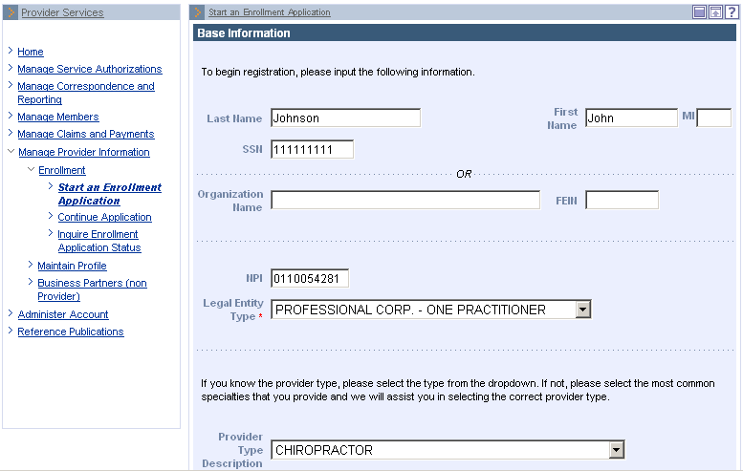

Administer Account
Administer Account lets providers change their password and add and update subordinate accounts.

When a provider allows others in their office to process transactions, such as claims and Prior Authorizations, they should be added as a subordinate account.
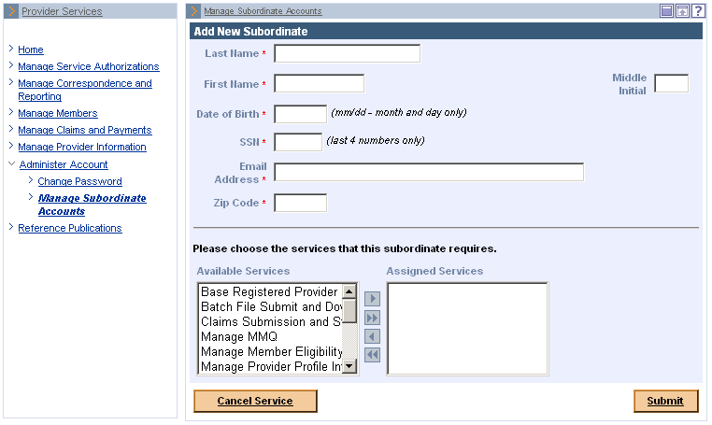

Reference Publications
Reference Publications contains standard forms for downloading, publications, registration for training, training materials, and MassHealth regulations. Download Forms provides access to standard forms for all providers, community health centers, durable medical goods, home health agencies, hospice, independent nurses, long term care, orthotics, outpatient hospitals, personal care, pharmacy, therapists, and transportation.
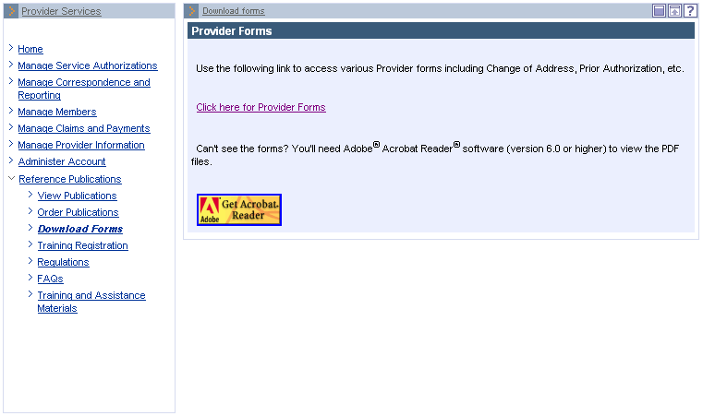
Searching for a Referral
Being able to retrieve the data stored in NewMMIS will be integral to helping you perform your job. Items such as member information, referrals, prior authorizations, and pre-admission screening requests are all searchable through the Provider Online Service Center. The following is a short procedure to guide you through how to search for a referral.
From the Provider Online Service Center home page:
- Click Manage Service Authorizations.
- Click Referrals.
- Click Inquire Referral. The Referral Search panel is displayed.
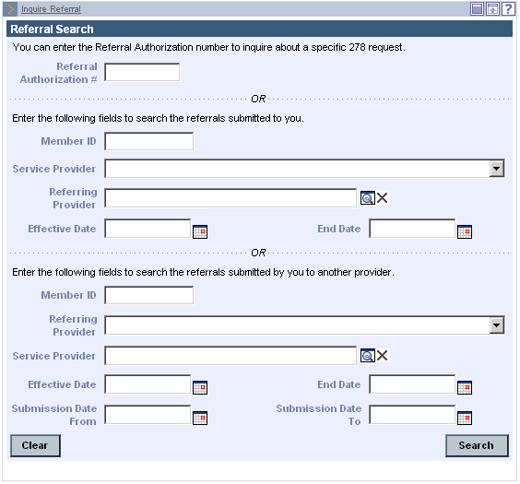
On the Referral Search panel:
- If you know the referral number:
- Enter the referral number in the Referral Authorization Number field.
- Click Search.
- Skip to Step 14.
- If you don’t know the referral number:
- Enter a Member ID of the referral.
- Select the Service Provider from the drop-down list.
- In the Referring Provider field, click the Field Search button ( ) to display the Search for Provider panel, where you can perform a search for the correct service provider.
On the Search for Provider panel:
- Enter the search criteria for the referring provider.
Note: For effective searching, enter as much search information as possible. You can search for referring providers using one or more of the following search criteria:
- Business Name
- Provider’s Last Name
- Provider’s First Name
- Gender
- City
- ZIP Code
- Provider ID or NPI
- Specialty
- Provider Type
- Click Search. The List of Servicing Providers panel is displayed.
On the List of Servicing Providers panel:
- Click the Name of the desired referring provider. The Referral Search panel is displayed, and the selected provider’s name appears in the Referring Provider field.
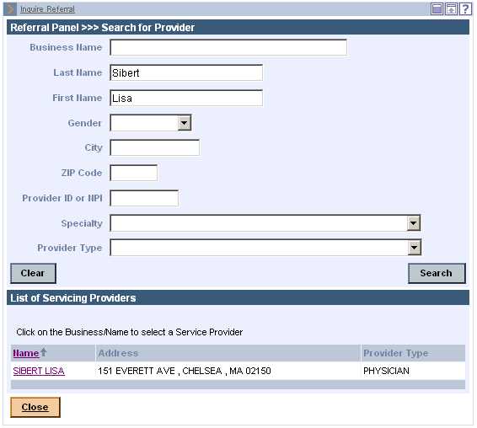
On the Referral Search panel:
- Enter the Effective Date of the referral.
- Enter an End Date for the referral.
- Click Search. The Referral Search Results panel is displayed.
On the Referral Search Results panel:
- Click the Referral Number link of the desired referral. The Referral Information panel is displayed.
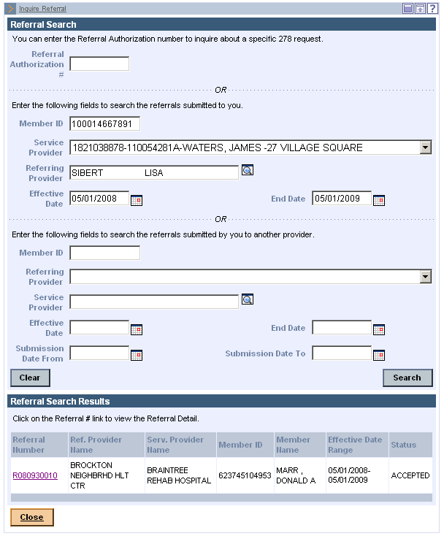
On the Referral Information panel:
- Review the referral information. When you have finished reviewing the referral, you can do one of the following:
- Click Cancel Service to go back to the Inquire Referral panel, where you can start a new search for a referral.
- Click Return to Search Results to go back to the Referral Search Results panel, where you can select another referral matching the current search criteria.

