NewMMIS Training Development

Storyboard

Functional Area: X
Course: X

Acceptance Criteria
From Training Plan Appendix A:

eLearning |  | Instructor Led Training |  | Job Aid

Performance Objectives: Criteria Met ? Y / N
Search for members
Inquire on eligibility
Explain the address hierarchy
View presence of TPL
View reports/notifications as appropriate

Training Considerations :
• Disenrolling a member from a current plan/provider prior to enrolling the member in the new plan/provider is a large training and operational issue – especially in conversions where hundreds/thousands of members are transferred.
• The concept of “opting out” will need to be fully investigated for training; this should include “opting out” in error.________________________________________

Audience : | All NewMMIS Users

Sign Off Log
Name / Date
Trainer
Style Guide Compliance Audit by:
EDS Training Manager
EDS BA
EDS Development Start Date
Handover Date to CW Functional Team
Returned to EDS Development End Date
Delivery Date with Final Changes to CW

Objectives:
When you complete this module, you will be able to:
- x
- x
- x
Storyboard:

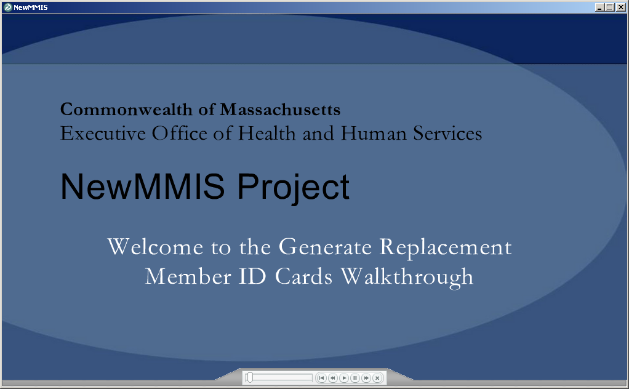 | Standard cover page with title: Welcome to the XX Walkthrough

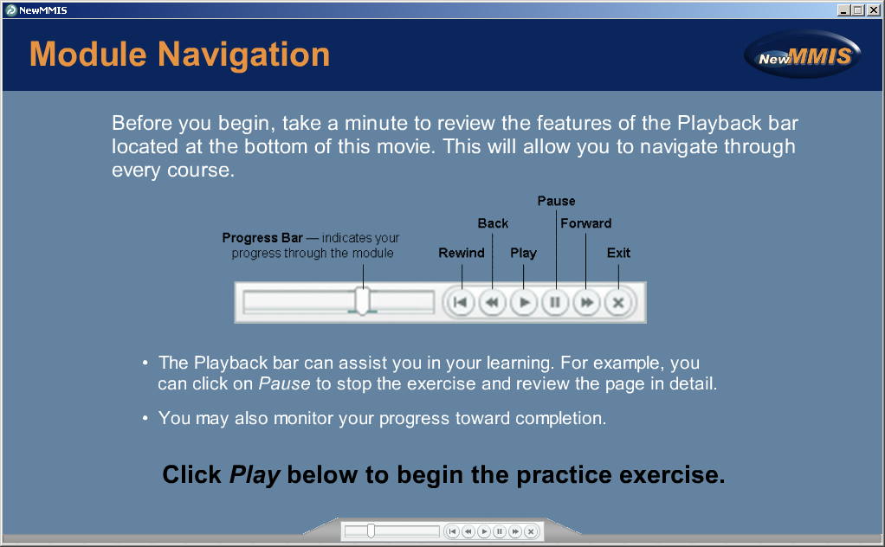 | Standard navigation page

X panel  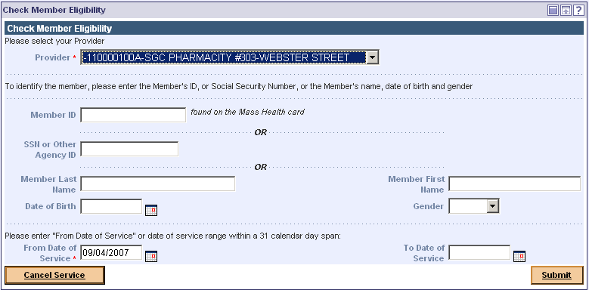 | Caption Box:  Image to left has the white boxes to indicate fade.  Red highlight box to show where to click.

